**Use Concise and Informative Titles**

**(use the font AdvOT1ef757c0 14 ptfon)**

**(The title uses an effective sentence with a maximum 15 words)**

First Author1* Second Author2, Third Author3 (12pt)

*1First affiliation, Address, City and Country (10pt)

2Second affiliation, Address, City and Postcode, Country (10pt)

3Third affiliation, Address, City and Postcode, Country (10pt)

*Email: Use First Author Email

|  |  |  |
| --- | --- | --- |
| **Article Info** |  | **Abstract** |
| ***Article History***  Accepted:  Approved:  Published: |  | ***Abstract:*** Unstructured abstracts are written in Indonesian in one paragraph, no more than 170 words, and must contain background and objectives, methods, main results and conclusions. Avoid using abbreviations and quotations. Use the AdvOT1ef757c0 font with size 10 pt, single or single spacing.  ***Abstrak:*** Abstrak tidak terstruktur ditulis dalam bahasa Indonesia dalam satu paragraf, tidak lebih dari 170 kata, dan harus memuat latar belakang dan tujuan, metode, hasil utama, dan kesimpulan. Hindari penggunaan singkatan dan kutipan. Menggunakan font AdvOT1ef757c0 dengan ukuran 10 pt, spasi 1 atau tunggal. |
| ***Keywords:***  First keyword  Second  Third  Fourth  Fifth.  Keywords are written in Indonesian, 3-5 keywords or phrases, arranged alphabetically, and do not use terminology that is too general or long-winded/long. Use with a font size of 12 pt. |  |

**Introduction (color) (bold, 12 pt)**

# Start with an explanation of the context or situation behind the research topic. Include recent developments in related political and public policy issues, why the topic is important, and how it is relevant in the current political, legal, or policy context.

# A very brief literature review of pre-existing solutions related to the topic at hand. Mention previous researchers or studies that have provided solutions, indicating the best researchers or approaches to date. Use this literature to clarify your research position and identify gaps or limitations in previous research.

# Identify limitations of previous solutions or research that you found in the literature survey. Explain where the solution is inadequate and why further research needs to be done to address the problem.

# After stating limitations, explain the purpose of your research. Explain clearly what you hope to achieve through this research. Focus on the novelty aspect or scientific contribution offered by your research in answering unanswered problems.

# Explain why the problem you are researching is important and why this research should be done now. Focus on the social, political, or policy aspects of urgency related to the problem.

# At the end of the introduction, clearly state the problem examined in your research. The problem statement must be concrete and specific so that readers know the main focus of your research. At least one aspect of the main problem must be studied and reviewed in depth in the research.

# Research Method (bold, 12 pt)

This method is written descriptively and must provide a statement regarding the research methodology, including the type of research, research approach, data sources and analysis methods. Authors must explain mechanisms for analyzing problems and exploring political and public policy issues. This method provides as much as possible an overview to the reader of the method used, this method is optional, only for original research articles. (For Conceptual Ideas Without Research Methods).

# Results and Discussion (bold, 12 pt)

# Results must be clear and concise. Discussions should explore the importance of deliverables, not rehash them. Avoid extensive quotations and discussions of published literature

**Table**: the table writing format must follow clear academic and professional standards. The following is an explanation of the important elements in writing tables according to the journal template:

The table title is placed above the table. Titles are usually written in Title Case format (capitalize the first letter of each important word) and do not end with a period. The title must describe the contents of the table concisely but clearly. In tables, use horizontal lines at the top and bottom of the table as well as lines that separate the table header (column title) from the contents. It is best to avoid using vertical lines unless necessary to clarify the contents of the table.

Each column must have a clear header or column title. Column titles are written briefly and clearly, with capitalization of the first letter of each word (if using Title Case) or capitalization of the first word (if using Sentence case). The data in the table must be arranged neatly and consistently. Make sure each number or text is aligned to the appropriate column and use center alignment.

Example:

**Table 1.** Themes grouped in clusters

|  |  |  |
| --- | --- | --- |
| **Cluster** | **Consepts** | **Total** |
| Cluster 1 | Corruption, democratization, factor, implementation, paper, peace, politic, research, system, transitional period. | 10 |
| Cluster 2 | Chapter, civil war, conflict, history, life, victim. | 6 |
| Cluster 3 | Commission, legacy, past, transitional justice, transitional justice mechanism, truth. | 6 |

*Source: Data processed 2024*

If there are additional explanations regarding the table (such as data sources, abbreviations, or symbols used), provide notes below the table. This note can be written in lower case format with a smaller font size than the main text.

The table must be adjusted to the column width of the journal page. Don't make a table that is too wide so it is difficult to read. If the table is too large, consider dividing it into two parts or adjusting the font size and layout without sacrificing readability.

Image Titles and Numbering: duls or descriptions of images and graphs are placed below the image or graph, in contrast to tables where the title is above and written in Sentence case (capital letters only at the beginning of the sentence) and do not end with a period. Each figure or graphic should be numbered sequentially, in the order they appear in the text of the article (for example, Figure 1, Figure 2, Graph 1, and so on).

Images and graphics must be of high enough resolution to print clearly (generally 300 dpi or higher for images to be published in print). Images in compatible formats such as JPEG, PNG, or TIFF. Avoid using non-standard formats such as GIF or BMP for scientific publications. Images should be adjusted to fit the column or page size of the journal without sacrificing the readability of important elements. If the image is too large, consider breaking it up or summarizing the important points.

Chart Title and Numbering: The type of graph used must be appropriate to the data you want to present. Example:

* Bar Chart: To compare several categories.
* Line Chart: To show changes in data over time.
* Pie Chart: To show distribution or percentage.
* Dispersion Graph (Scatter Plot): To show the relationship between variables.

Graphs should be accompanied by adequate description, including X and Y axis titles, a clear scale, and a legend (if necessary) to explain the data presented.

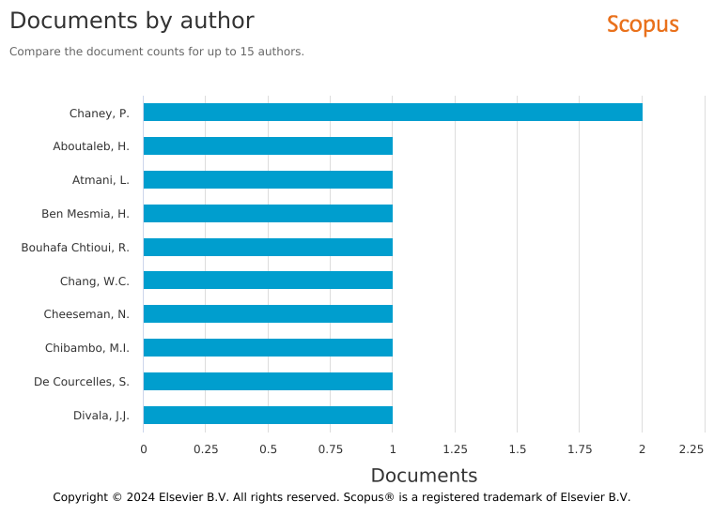Example:

**Figure 2**. Research trends based on years of scopus on the concept of citizen democracy in some countries (Scopus 2024)

Image or graphic captions should include brief explanations but be detailed enough to help readers understand the visuals without having to read the entire text of the article. Captions can include information about the data source (if the image or graph is created from external data), a brief explanation of what you want to show, as well as other relevant important things. If the image or graph is taken from another source (for example, a map, an image from literature, or a graph from another study), you must clearly include the credit or source in the image or graph caption.

**Writing Example Source: Source: Data adapted from World Health Organization, 2021.**

Any images or graphics included in an article must be referenced in the text. Image references should be written like this: (see Figure 1) or (see Figure 1). This makes it easier for readers to find relevant images or graphics while reading.

**Discussion**

The discussion section explains, interprets, and provides further insight into the research results. A good discussion writing format usually includes the following elements:

#### Start by presenting an interpretation of the research results presented previously. Explain what the results mean in the context of the research and how they answer the research questions asked. Don't just repeat the results, but provide a more in-depth analysis of the implications of those results.

#### Discuss how your research results match or differ from relevant previous research findings. Are there significant differences or similarities that attract attention? List studies that support or challenge your findings, and explain why. If there are differences in results, provide arguments that might account for the differences (e.g., different methodology, different context, or other variables).

Explain the impact or implications of the research results in the context of the theory used. How do these findings contribute to the development of existing theory or literature? If the research results have practical implications (for example, public policy), discuss how the results can be applied in practice or how they can influence policy decision making.

State any limitations of the study that may affect the results or generalizability of the findings. For example, limitations in sample size, methodology, or variables that cannot be controlled. Explain how these limitations may affect the results and provide recommendations for future research to address these limitations.

Provide suggestions for further research that can deepen or continue the studies already conducted. These recommendations may include methodological suggestions, untapped areas of research, or new perspectives worth exploring.

**Conclusion**

Summarize the main findings of the research concisely, without including new information. The general structure of the conclusion consists of the following points:

Summarize the main findings you discussed previously. Focus on the most important results that directly answer the research question. Don't repeat the entire contents of the discussion, but only emphasize the main points.

Example:

This research finds that education policies in ASEAN countries tend to be more effective when supported by strong community participation, compared to top-down policies.

Emphasize the impact or contribution of research results, both from a scientific perspective (contribution to theory) and practical (implications for certain policies, decisions or practices).

Don't add new discussion here, just summarize the impact briefly.

Example:

The results of this research provide an important contribution to understanding how participatory policy design can improve implementation effectiveness in various public sectors.

If relevant, provide policy recommendations or practical actions based on the results of your research. This is especially important for journals that focus on public policy.

Example:

The government needs to consider more inclusive citizen participation mechanisms to increase the effectiveness of future education policies.

Conclude the conclusion with a brief statement about the importance of this research in the broader context. For example, how this research can open up opportunities for further study or how the results are relevant in facing challenges currently being faced in public policy.

**Reference**

Use the format for writing references and citations in APA 7th Edition style which is generally used in international journals, including for articles in the fields of politics and public policy**.**

**APA Reference Format (7th Edition)**

The following are examples of reference formats for various types of sources in APA 7th Edition style:

**a. Journal Article**

* Format:

**Author, A. A., Author, B. B., & Author, C. C.** (Year). Title of article. *Title of Periodical*, volume number (issue number), pages. https://doi.org/xxxxxx

* Example:

Smith, J., & Wesson, R. (2021). The impact of public policy on economic growth. *Journal of Politics and Public Policy*, 10(2), 34-45. https://doi.org/10.1234/jppp.2021.56789

**b. Books**

* Format:  
  **Author, A. A.** (Year). *Title of work: Capital letter also for subtitle*. Publisher.
* Example.

Jones, M. (2019). Global governance: Challenges and opportunities in the 21st century. Cambridge University Press.

**c. Chapters in Edited Books**

* Format

**Author, A. A., & Author, B. B.** (Year). Title of chapter. In E. E. Editor (Ed.), *Title of book* (pp. pages of chapter). Publisher. https://doi.org/xxxxxx (if applicable)

* Example:

Lee, S., & Johnson, R. (2020). Public policy reforms in East Asia. In M. Brown (Ed.), *Policy innovation in Asia* (pp. 56-78). Oxford University Press.

**d. Government or Organizational Reports**

* Format:

Name of Organization. (Year). Title of report. Publisher. https://doi.org/xxxxxx (if applicable)

Example:

World Bank. (2020). *World development report 2020: Trading for development in the age of global value chains*. World Bank. https://doi.org/10.1596/978-1-4648-1455-2

**e. Online Sources (Web Articles or Blogs) e. Online Sources (Web Articles or Blogs)**

* Format:  
  **Author, A. A.** (Year, Month Day). Title of web page. *Website Name*. URL
* Example:

Anderson, J. (2022, March 15). How digital policy influences the global economy. Digital Policy Insights. https://www.digitalpolicy.com/articles/economy

**2. In-Text Citation Format**

The citation style in the text in APA 7th Edition uses the author-date method, where you include the author's name and year of publication in brackets. There are two types of citations in the text:

**a. Narrative Citation**

The author's name becomes part of the text, followed by the year of publication in brackets.

**Example:**

According to Smith and Wesson (2021), public policy significantly impacts economic growth.

**b. Parenthetical Citation**

The author's name and year of publication are placed together in brackets after the text you are citing.

**Example:**

Public policy has been shown to significantly impact economic growth (Smith & Wesson, 2021).

**c. Citations for Sources with Three or More Authors**

For sources with three or more authors, you only include the name of the first author followed by et al. and year.

**Example:**

The findings were consistent with previous studies (Johnson et al., 2018).

**d. Citations with Specific Pages**

If you are citing specific pages from a source, add the page number after the year in the citation.

**Example:**

(Smith & Wesson, 2021, p. 40).

1. **Writers are advised to use tools in writing and managing papers**

Authors are required to use one of the popular reference tools to ensure the citations and reference list in the manuscript comply with APA 7th Edition standards. The following tools are recommended: Reference Tools (Zotero, Mendeley, EndNote, or Citation Machine)